
School of Engineering
Statistical Analysis and Modelling

Report Title: Image Style Transfer in Convolutional Neural Networks by using PyTorch and TensorFlow

Table of Contents:
Abstract
Introduction
Literature Review
Experimental Methods
Machine learning Methods (PyTorch and TensorFlow)

Difference between PyTorch vs TensorFlow: 5
What is Convolutional Neural Network …………………………………………………………………………………….
Implementation
Implementation of CNN in PyTorch…………………………………………………………………….
Implementation of TensorFlow for CNN…………………………………………………………
Conclusion and Discussion…………………………
References………………………………………………………………

Image Style Transfer for in Convolutional Neural Networks by using PyTorch and TensorFlow

- Abstract: Deep Neural Network or Deep learning refers to the Artificial Neural Network (ANN) with different layers. Infact, it is considered as most powerful tool and is popular because of its capacity to handle the huge datasets. The interest of having deep hidden layer has recently started that surpass the classical method performance in different field and peculiarly in Image Style Transfer. Moreover, the most commonly used and popular deep neural network is Convolutional Neural Network, and its name is because of the linear mathematical operations between matrix which is termed as convolution. It has various layer that included non -linear layer, fully connected layer, polling layer and convolutional layer. Fully connected and Convolutional layer have parameters but non-linear and pooling do not have parameters. In various machine learning problems CNN has an excellent performance and especially in the application which deals with images data like computer vision, natural language processing (NLU), image classification dataset and amazing results are achieved. However, the limitations from the previous research has resulted in the lacking of image representation that makes use of semantic information and hence results in separating image content from style. In this article, I have implemented Image Style Transfer by using Convolutional Neural Networks by using PyTorch and TensorFlow. To build neural networks with the Python language, PyTorch is used and has recently spawn tremendous interest in machine learning because of its flexibility and simplicity. On the other side, TensorFlow is open-source deep learning and machine learning framework and is flexible for CNN image style transfer because of its capability to extract powerful features of convolutional blocks. In this paper I have explained and defined all the elements of PyTorch and TensorFlow and the implementation and execution of CNN by using PyTorch and TensorFlow in Python

Here we use image representations derived from Convolutional Neural Networks optimised for object recognition, which make high level image information explicit. We introduce A Neural Algorithm of Artistic Style that can separate and recombine the image content and style of natural images. The algorithm allows us to produce new images of high perceptual quality that combine the content of an arbitrary photograph with the appearance of numerous well-known artworks. Our results provide new insights into the deep image representations learned by Convolutional Neural Networks and demonstrate their potential for high level image synthesis and manipulation.

- Introduction:
From the past, the results of Convolutional Neural Network are ground breaking in different fields which are pattern recognition; that ranges from image processing to voice recognition. The most important advantage of CNN is it reduces the ANN’s parameter numbers. Hence, to solve complex tasks, researchers and developers has prompted an approach for larger models which was not possible with classis ANN’s. The important aspect is that CNN solves the features that are dependent spatially. In simpler words, for an instance; for application of face detection, there is no need to focus the location of faces in images. |The concern only is to detect them regardless of their position in the image. The other CNN aspect is the extract feature when an input propagates towards the deeper layers. To emplify; in classification of image, in the first layers the edge might be detected and in second layer the simpler shapes and then, in the next layer the higher-level features are classified.
Image style transfer from one image to another is considered as texture transfer problem. In this, the goal is texture synthesise from the image source by constraining the texture synthesis that preserves the semantic content of the target image. For this a big powerful range of non-parametric algorithm exists that synthesizes photo-realistic natural textures by re-sampling source texture pixels. However, most of previous algorithms use non-parametric methods for texture synthesis by using different ways which preserves target image structure. For this in my Research, I will be transforming the content image to Input image in CNN by using PyTorch and TensorFlow. PyTorch, a library that specializes in Natural language processing and deep learning is developed by Python. To implement deep neural networks, it takes the advantage of processing graphical processing units which is faster then training a network on a CPU. Also, PyTorch package is similar to NumPy, along with the addition of GPU’s. The recent release of PyTorch is Pytorch 1.0 that aims to assist developers and researchers by addressing major challenges like, Time consuming training, extensive reworking, slow scale up and Python programming language inflexibility. On the other hand, TensorFlow is a widely used framework that was developed by google and its latest release is TensorFlow 2.0. The most available software applications are almost open source along with Apache 2.0 licence. TensorFlow has several interfacing languages like C, C++, Python and CUDA along with different visualizing and cross platform compilation.
The structure of the report is organised as Section2 as Literature Review, Section 3 as Experimental Methods which includes my implementation of PyTorch and TensorFlow, Section 4 is the Conclusion and Discussion section.
- Literature Review:
This section highlights the researches conducted on PyTorch and TensorFlow on Convolutional Neural Network and in the recent years CNN has gained incredible popularity in various domains like image classification and Image Style transfer. Moreover, there are various researches done on several types of neural networks.
A research on CNN was done, in which neural network classifies 1.2 million high resolution image in the ImageNet LSVRC-2010 contest into the 1000 different classes. In this, neural network has 60 million parameters and 650,000 neurons, consists of five convolutional layers, some of which are followed by max-pooling layers, and three fully connected layers with a final 1000-way SoftMax. To make training faster, implementation of non-saturating neurons and a very efficient GPU implementation of the convolution operation (Alex Krizhevsky, 2017). This research achieved top-1 and top-5 error rates of 37.5% and 17.0%, respectively, which is considerably better than the previous state-of-the-art.
A research on RNN( Recurrent Neural Network) for automatic speech recognition was implemented by using TensorFlow in which RNN-T loss and its gradient with respect to the SoftMax outputs were computed efficiently using a forward-backward algorithm by using CPU, GPU and TPU (Bagboy, Rao, & Sim, 2018). In this the same optimization was applied to compute the RNN-T Viterbi alignment and concluded that by increasing the batch size from 1 to 32, throughput performance by 22.9 times on GPU and 3.2 times on GPU.
An article on state-of-art of Speech recognition was published and PyTorch was used to build neural network in Python that has tremendous interest in machine learning because of simplicity and flexibility (Ravanelli, Parcollet, & Bengio, 2019). The PyTorch-Kaldi project aims to bridge the gap between Kaldi and PyTorch toolkits, trying to inherit the efficiency of Kaldi and the flexibility of PyTorch. The research confirmed that PyTorch Kaldi achieved state-of-art result in some popular speech recognition tasks and datasets.
A paper was published which aimed to extend fast neural network style transfer to multiple styles in which first single style transfer was implemented and then extension to multiple style transfer by training the network to learn the parameters that blends the weights (Cui, Qi, & Wang). But the limitation of this was, , it is still limited to a fixed selection of style images to be trained on, followed by a very long training process of a few hours.
A paper for Neural Network was implemented where they made a comparison on Public Transportation Prediction in PyTorch and TensorFlow and compared Four Neural Networks, two machine learning models and two deep learning models both in PyTorch and TensorFlow (Heghedus, Chakravorty, & Rong, 2019) .The results stated that TensorFlow is slightly better than in terms of accuracy , whereas, PyTorch is easier and faster to implement.
A Deep learning was implemented in CNN and SoftMax by using TensorFlow where they implemented functions like Hyperbolic Tangent (tanH), Exponential Linear Unit (eLu), softplus sigmoid, softsign and Rectified Linear Unit (ReLu) (Ertam & Aydın, 2017). The research concluded that ReLu function is the most accurate classification rate function.
A Article on TensorFlow was published that detects training issues in neural network programs (Braiek & Khomh, 2019). The results stated that TFCheck, a TensorFlow based library can successfully detect issues in Machine Learning code.
4. Experimental Methods
4.1 Machine learning packages:
Artificial Neural Network is the heart of Deep Leaning which can be implemented in PyTorch and TensorFlow by Python. There are various achievement on neural network and the remarkable one’s are the ones that includes reaching state-of-art performance is with CNN on ImageNet dataset and was implemented in PyTorch and TensorFlow. The trained model can be used in in various applications like image semantic segmentation, object detection and many more. Moreover, the results of neural network implementation will not be same with any of the frameworks. In this, the training process different parameters are required which are dependent on framework. For an instance; in PyTorch, for training datasets, training process can be enhanced by implementing GPU’s as they run on CUDA. On the other side, TensorFlow is can access GPU’s but it has its own inbuilt GPU acceleration and hence, the training of models depends on the framework chosen.
4.1.1 PyTorch:
PyTorch is one of the most widely used deep learning library and is open source and today, is the leading one with its contender TensorFlow in the minds and the heart of the Artificial Intelligence developers everywhere. This popularity is due to its dynamically computational graph, simplicity , efficient memory usage and ease of usage and due to the rise of PyTorch . Also PyTorch is more efficient deep learning framework for many devices for distribution of training process (Mahon, Varrette, Plugaru, Pinel, & Bouvry, 2020).
Dominance of PyTorch is increasing and was developed by Facebook by using Torch library, at Artificial Intelligence- Research lab in October 2016. This machine learning is Torch based, a script language and a scientific computing framework that based on Lua programming language. The current version of PyTorch is 1.4 and it also incorporates Caffe2 which is a toolset for deep learning. From the past 3+ years PyTorch is dominating ones and had continued to build momentum and adoption among AI developers machine leaning and deep learning applications.
4.1.2 TensorFlow:
TensorFlow was developed by Google and based in Theano library, of deep learning for data flows as well as differentiable programming for various tasks range. Infact, it is symbolic math-library as well as machine learning application like neural networks that uses TensorFlow library and the primary usage of it is production and research. Infact, recent work says that TensorFlow is performs best in server grade multi thread implementations (Shaohuai Shi, 2016).The components of TensorFlow are Tensor and Graph and below are the features of TensorFlow:
ML Production Anywhere: In this the training and deployment of the models is there on cloud , in premises, on device or in browser or on device irrespective of end users language. Moreover, TensorFlow has higher storage availability and high processing because of which TensorFlow is fast and light weight network for object detection (OLIVEIRA, FERREIRA, & MARTINS, 2017).
Robust Experimentation for Research: A straightforward and flexible architecture which takes new idea from concept to code, to state-of-art models and publication faster.
Secure Model Building: Using intuitive high-level APIs such as Kera’s, the library allows us to build and train ML models, which makes for quick model iteration and easy debugging.

4.2 Difference between PyTorch vs TensorFlow:

Computational Graph Construction:
PyTorch allows to create graphs dynamically and the graphs are built, interpreting line of code corresponding to that particular graph aspect. But, in TensorFlow graph construction is static and, in that graph, goes through compilation and is then executed on execution engine. This means that user has to first define the computational model of the graph and the can be run, however, in PyTorch the graph model definition and manipulation is dynamically.
Debugging :
Debugging in TensorFlow can be taken place in two ways like required to learn TF debugger and requesting variables that are requested from the session. But, in PyTorch, the user is not required to use of any new debugger from scratch.
Serialization :
In PyTorch, a simple API saves all model weights or pickle the class entirely. However, in TensorFlow has a advantage that the entire graph will be saved as protocol buffer that includes operations and parameters. Moreover, the languages supported are Java and C++ and TensorFlow is majorly used for deployment stacks where Python is not available. Also, the model can be reused when the user wants to change the source code but want to run the older models.
Coverage:
PyTorch has very few features for coverage when compare to TensorFlow, However, TensorFlow has support of high level of functionality and gives broad spectrum of options to work and provides various operations like checking tensor for infinity and Nan , provides support for fast Fourier transforms and flipping a tensor along with the dimension.
Device Management :
In PyTorch, if CUDA is not installed, the user is required to move all the things onto the device explicitly. TensorFlow has a negative side in terms of device management in which if one GPU is in use then it still consumes all the GPU’s memory available.
Visualization:
Visualization is the important aspect for any project for any organization. In TensorFlow, Machine learning models are visualized in Tensor Board that aims to train the model and spots the error quicker and it is a real time graphs representation that states the graph and accuracy in graphs in real time.

Deployment :
Both frameworks are easy to wrap in case of small-scale server-side deployments. TensorFlow works well for mobile and embedded deployments. However, deploying to Android or iOS does require a non-trivial amount of work. Another noticeable feature that TensorFlow serves is that the models cannot be hot-swapped easily without bringing the service down.
Implementation and Experimental Setup:
A powerful technique for training deep neural networks that allows one to take knowledge learned about one deep learning problem and apply it to a different, is Transfer Learning. By using it we can dramatically speed up the application deployment rate which ultimately makes training as well as the implementation of Deep Neural Network easier and simpler. In this report, we will go through one example of image style transfer of transfer learning on Convolutional Neural Networks (CNNs) in PyTorch and TensorFlow.

5. What is a Convolutional Neural Network?
Convolutional Neural Network excels at manipulating image data and adept at creating the representation of visual data. The data in CNN is in the grid form that consist of values which represents how bright as well as which colour, and each pixel image. It has three components like fully connected layers, pooling layers and convolutional layers:

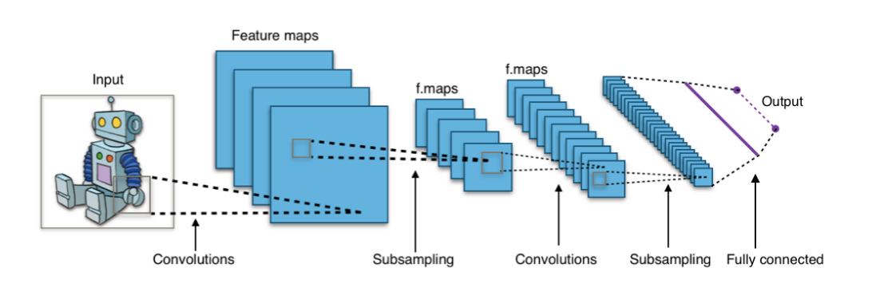
6. Implementation
6.1 Implementation of CNN in PyTorch:
Implementation in PyTorch starts with installing PyTorch in the Python and then importing the necessary libraries. They are as stated under:

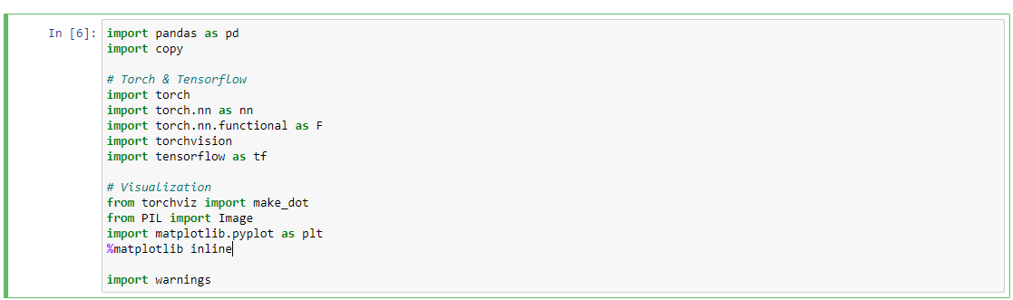
Next is the configuration of PyTorch, where we need to check whether CUDA GPU is available or not:

Then, creating an image loader for PyTorch, by using midsize

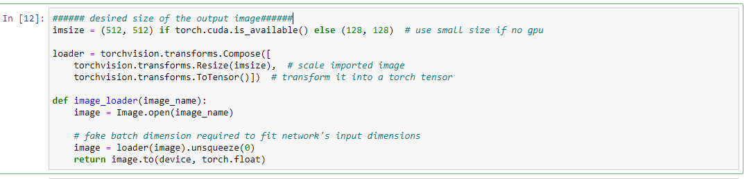

Next, PIL image an Plot tensor image needs to be defined
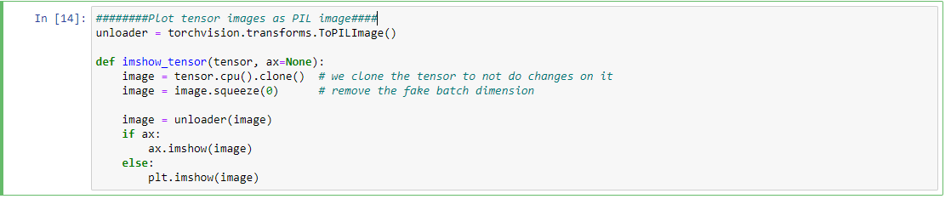

Need, to define content and style loss functions for content and style image:
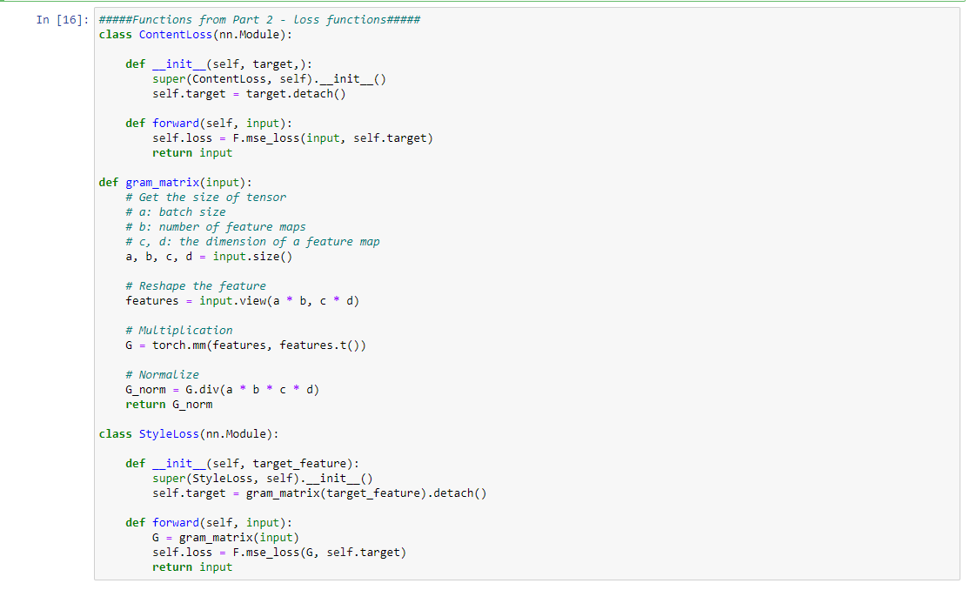Finally, a model need to implemented and here, I have used CNN and wrote the function to calculate mean and standard deviation:
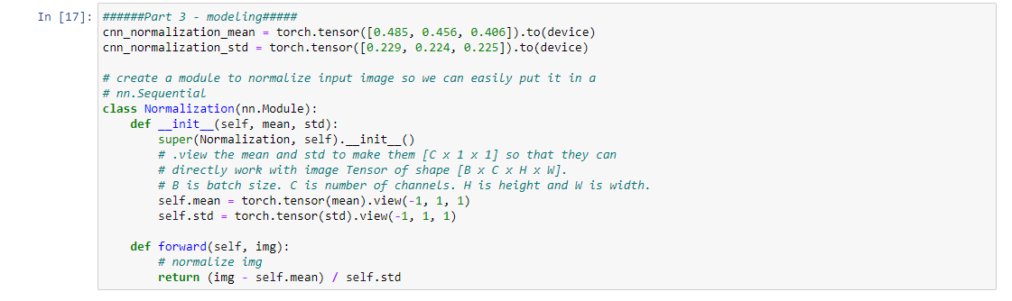
Next, comes is creating a sequential model for style transfer and in this I have defined the desired depth layers to compute the style or content loss:
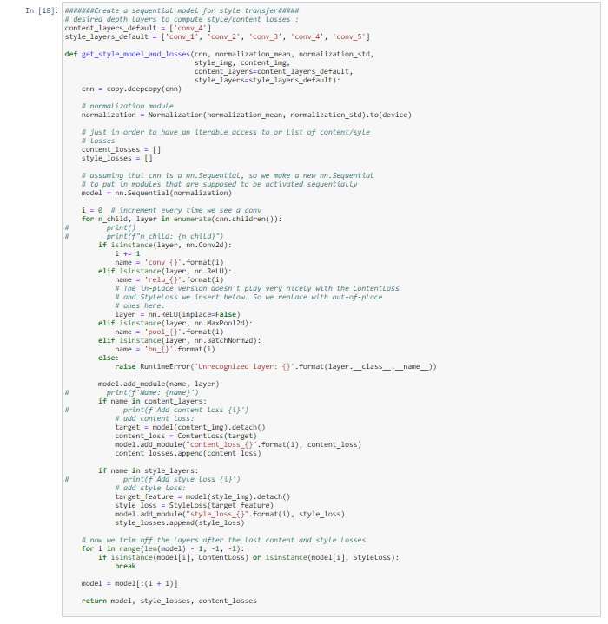
Then the images needs to implemented:
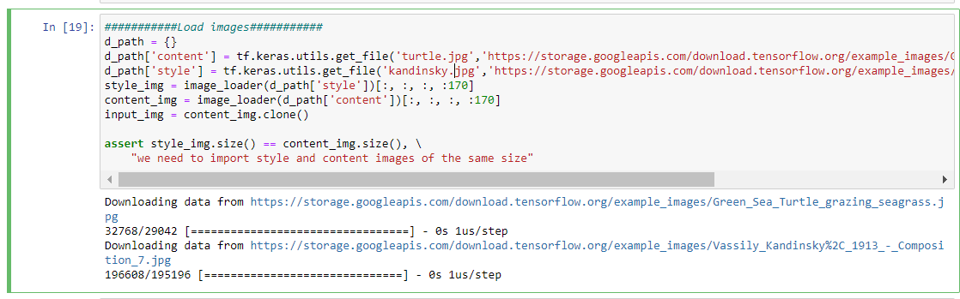Model for Style transfer without warning needs to be built:
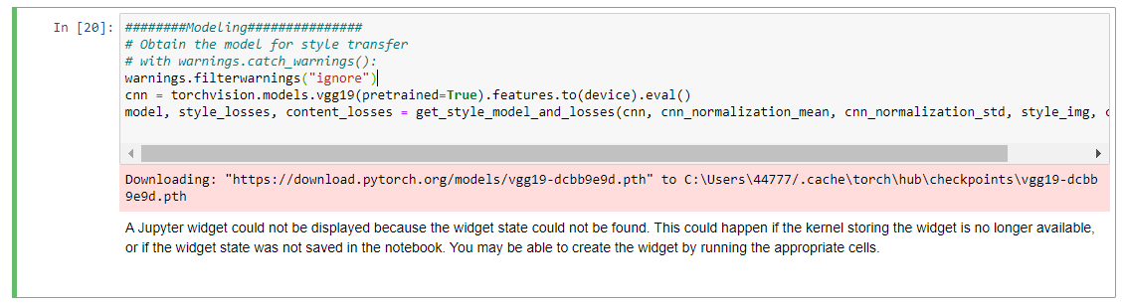
Creating the functions for Gradient Descent:
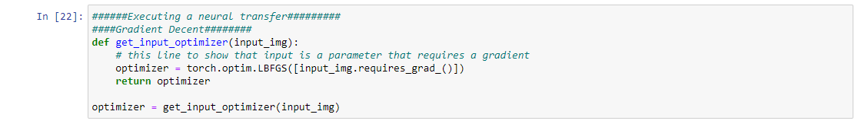
Next, specifying the parameters, namastes, style_weight, content_weight etc:
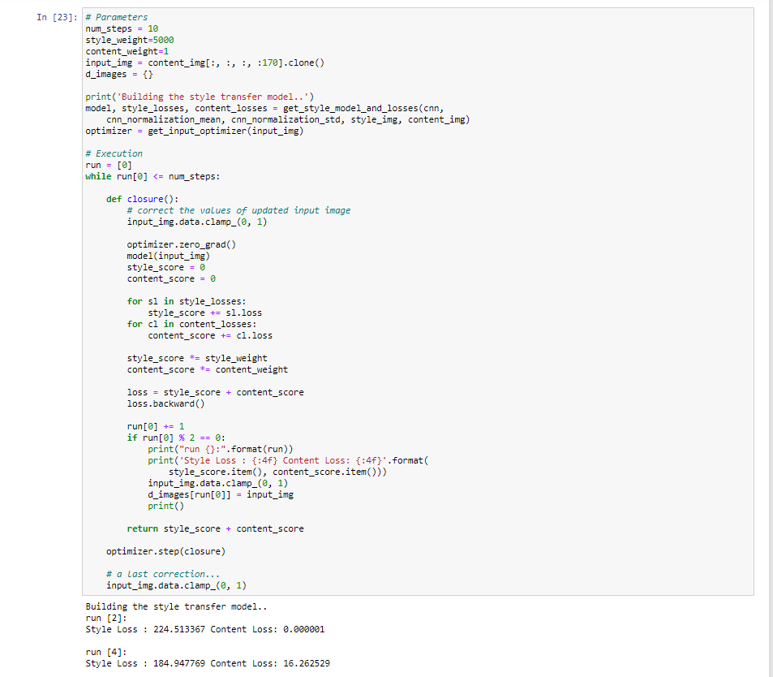
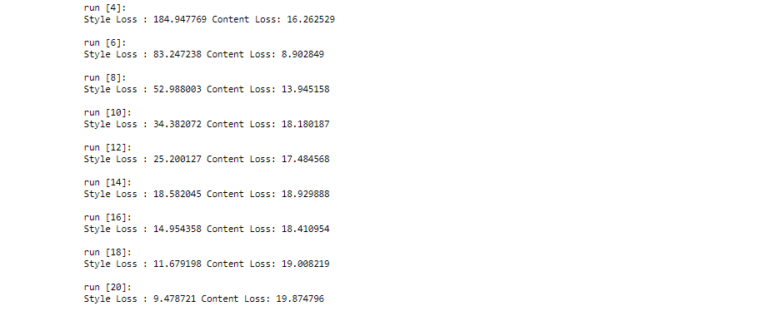
Now, we need to plot the Content Image, Style Image and output Image:
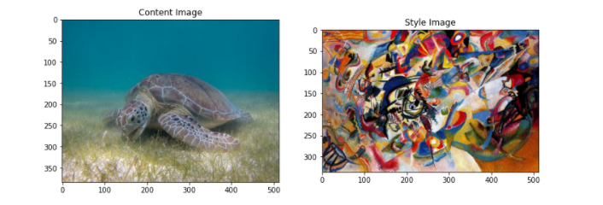
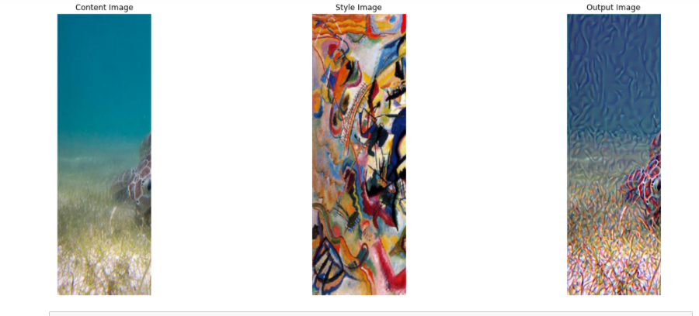
Last, is the visualization of Image style transfer:
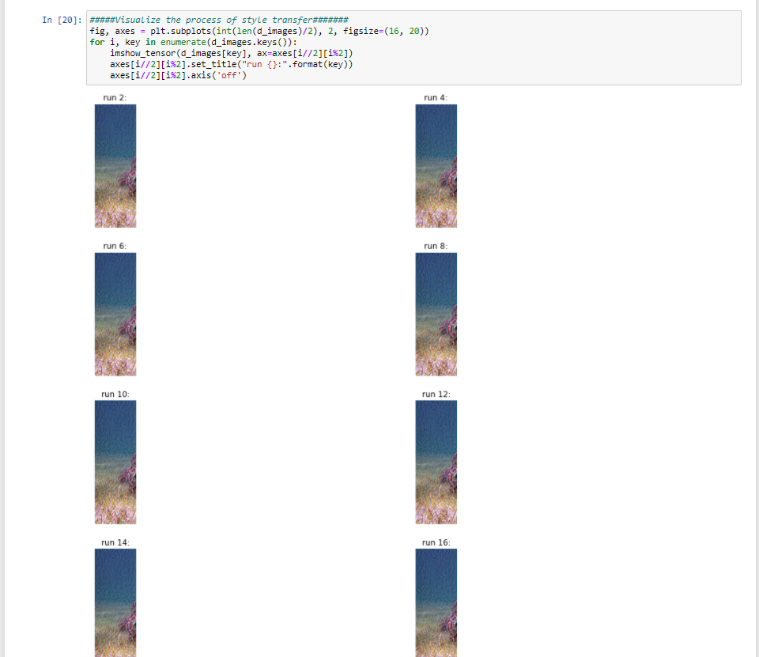

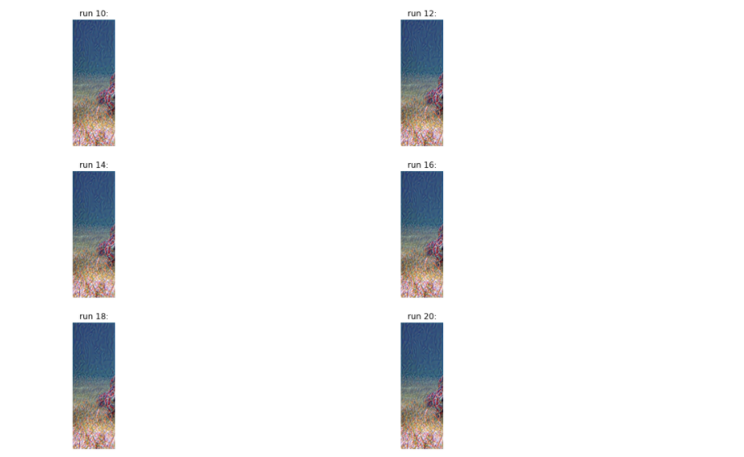

6.2 Implementation of TensorFlow for CNN:
To use TensorFlow in Python, the first step is to install that in Jypter CMD prompt and then load the necessary libraries and their configuration:
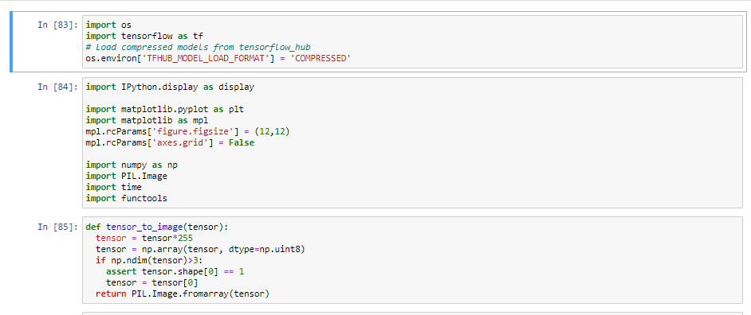
Next step, is to download and select style image and content image:
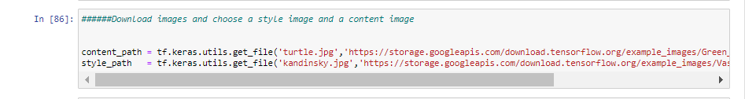

Then visualizing the input by defining the function to load the image where its limit is at the max of 512:
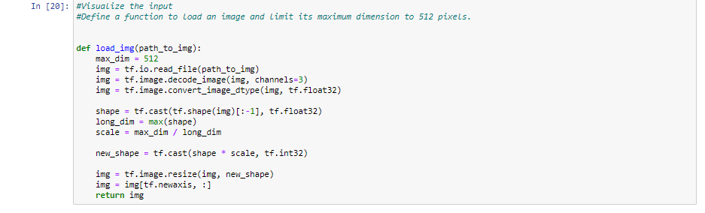
After loading image, need to create a simple function to display the image:
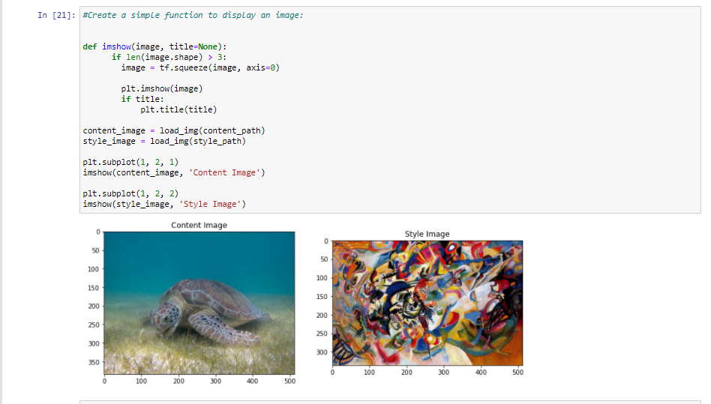
Next step is to use a style and content image and do fast image style transfer on the above :
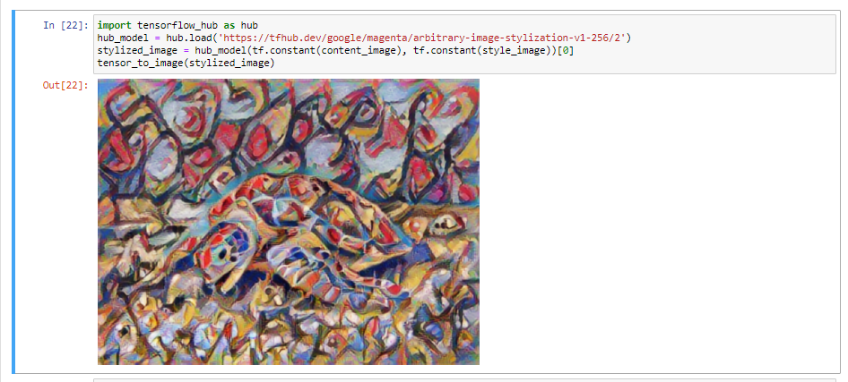
Now we need to define style and content representation of the image and for this we need to use intermediate level. Starting form network input layer, some of the first few activation layers state the low-level feature like textures and edges. Now, as we move further the end few layers would be representing high level feature like objects as eyes or wheels. For this, I have used VGG19 network architecture and for these intermediate layers are important as they are required to for definition of style and content from image. Hence, for this we need to load VGG19 to validate on our image and verify that it works correctly:
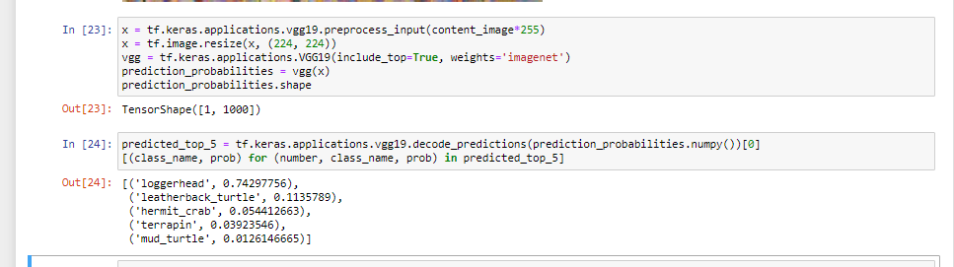
Next, VGG19 needs to be loaded with without any classification head and need to list the layer names:
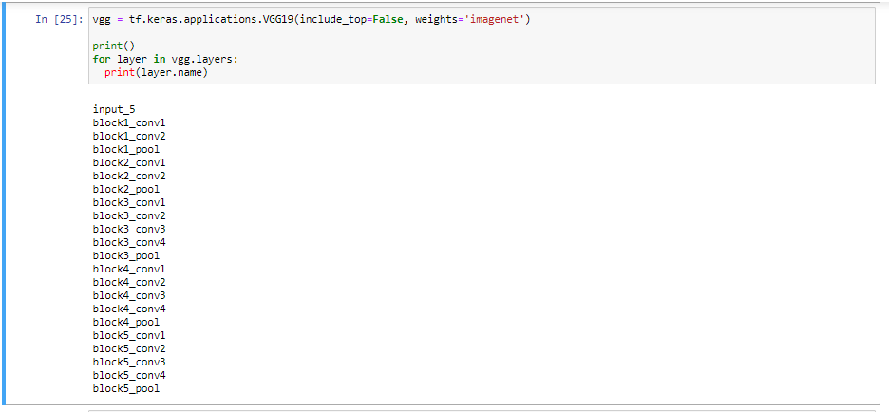
Then we need to choose intermediate layers from network to represent content and style of image:
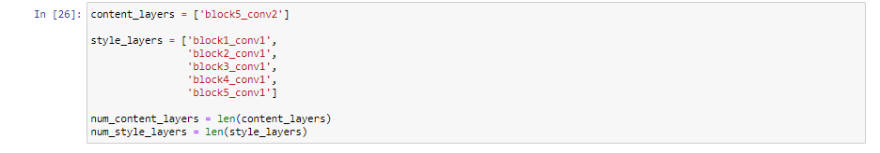
Other step now is to build the model by the networks in tf.keras.applications by using functional API’s and this will make the extraction of intermediate layers easy because of the Kera’s API’s. Now the next screenshot is the one that is for function building that returns intermediate output layers:
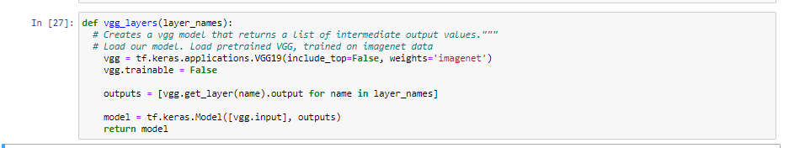
Creating a Model is done as stated under:
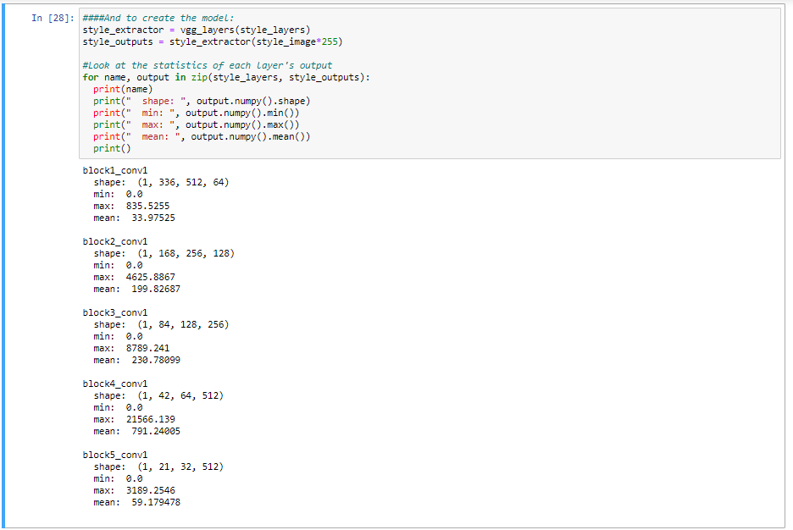
Calculate style:
In this Gram Matrix is calculated which takes outer product of the feature vector and averaging it to all the locations . The formula for gram matrix can be stated as under:
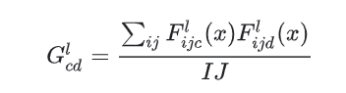
The implementation of gram matrix in TensorFlow can be done by using tf.linalg.einsum function and is as stated under:


Next comes extraction of content and style image:
For this I have build model, that returns content and style tensors:
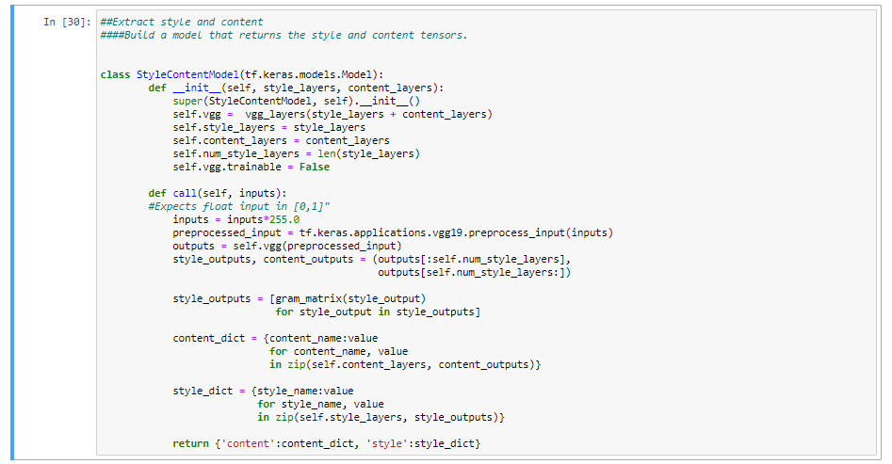
This model returns gram matrix (style) and for the style layers and content layers, when as image is called:
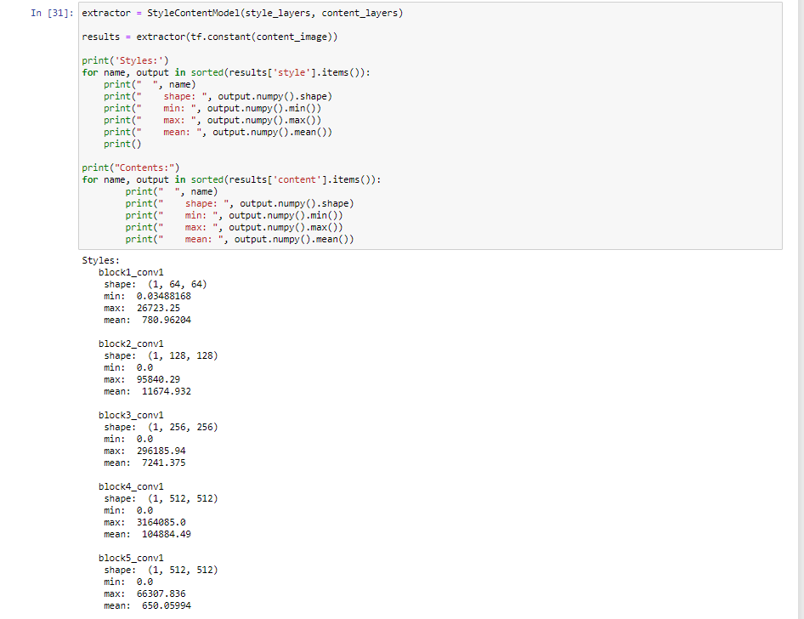
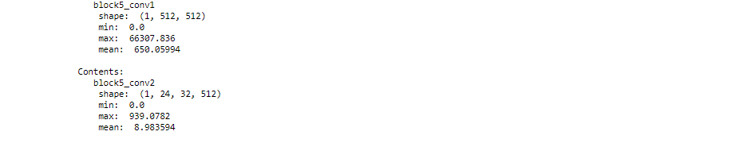
Run Gradient descent:
Now, with content and style extractor, style transfer algorithm have been implemented and for this mean square error for image’s relative output and then calculate the sum of the losses of their weights and setting the content and style values for target.
Then, for optimizing image, tf.variable and for quicker I have initialize content image :
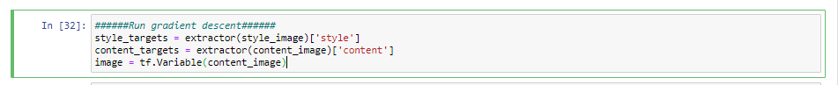
For keeping the pixels values in 0 and 1, I have defined a function as it is float value and then created optimizer and for that I used two losses weight combination:
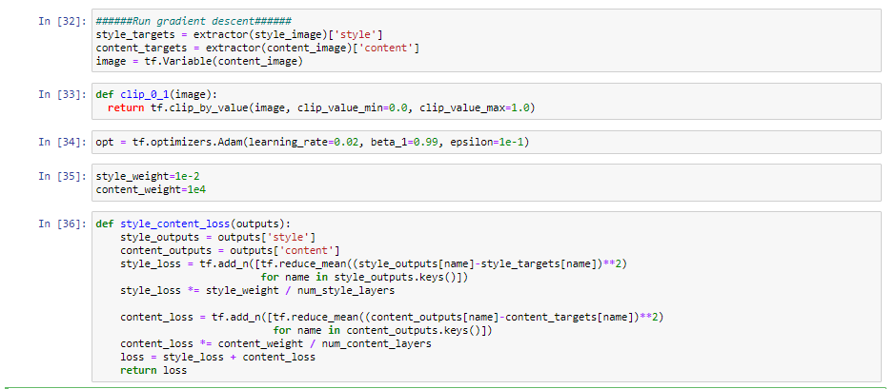
Now, for updating the image, tf.GradientTape as below:
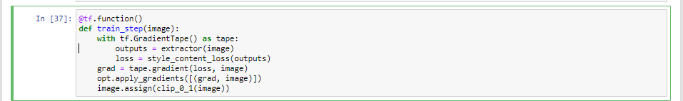

Need to test several times for better optimization:
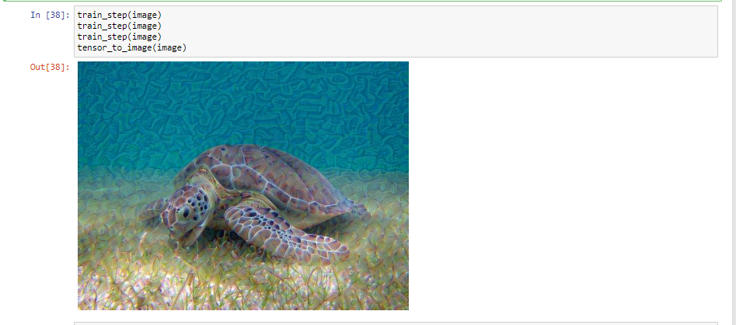
Now, as it is working fine need to perform longer optimization:
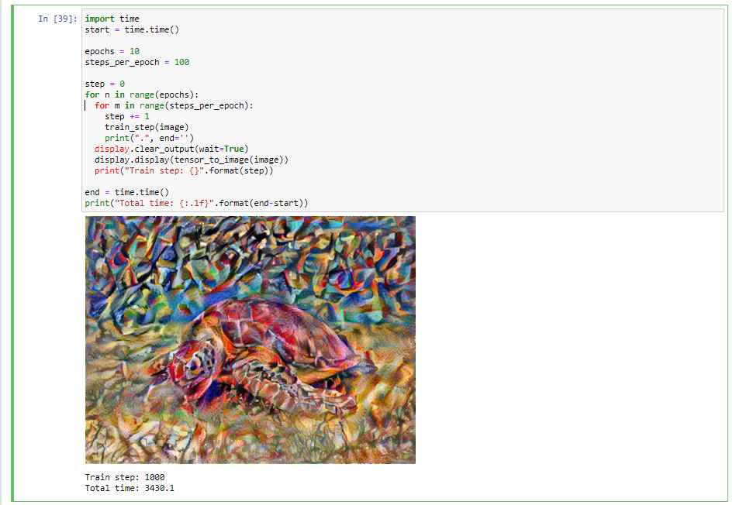
Last step is to calculate Variation Loss:
For this, for high frequency I have implemented explicit regularization term, and this is usually called as variation loss:

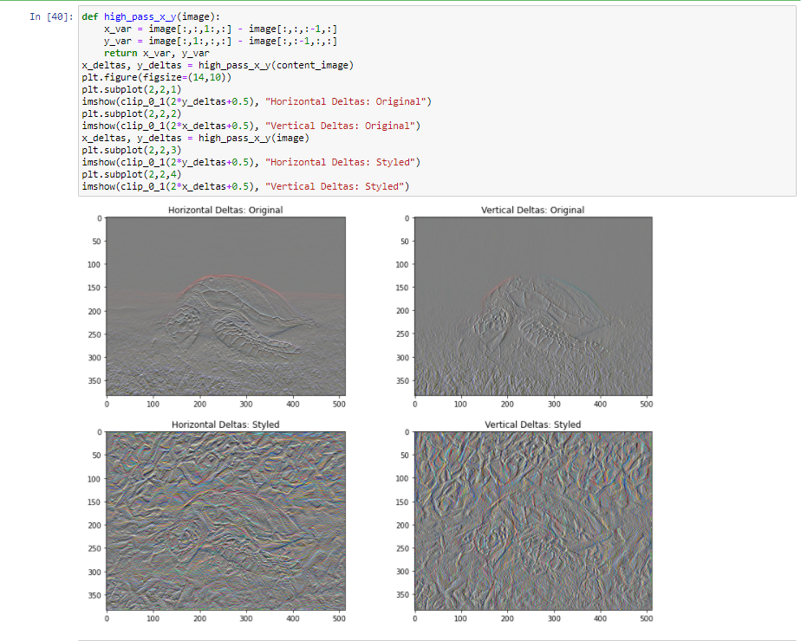
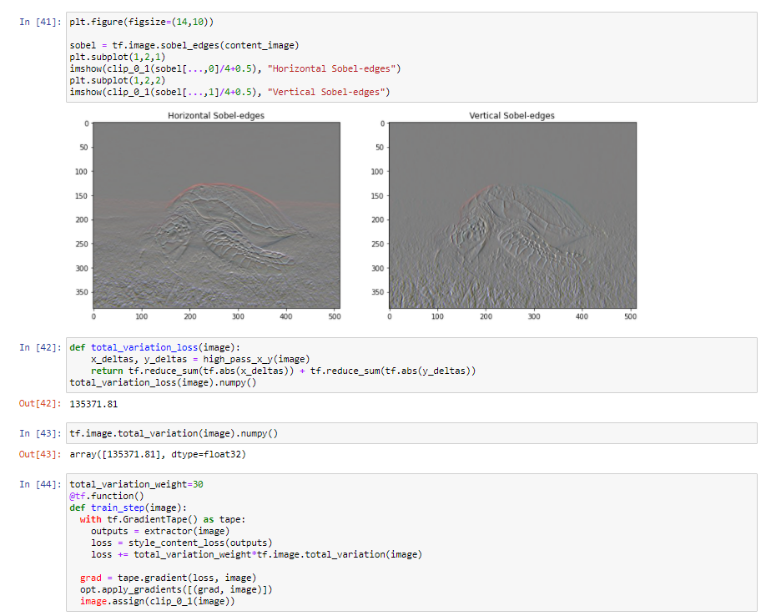
Next, rerun and reinatilze weights:
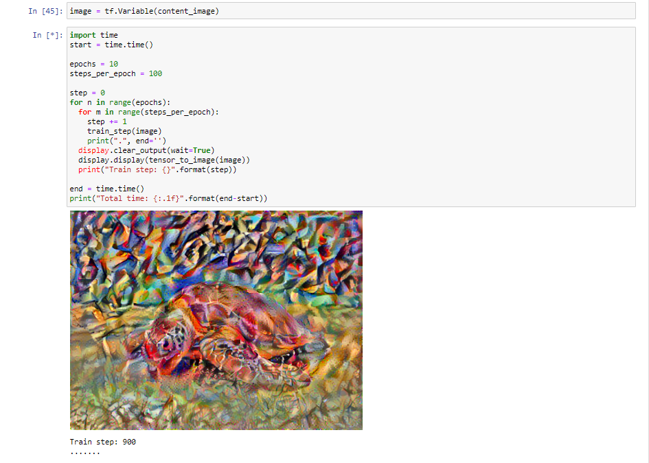
The code files for both PyTorch and TensorFlow are attached:

7. Conclusion :

PyTorch and TensorFlow are huge frameworks and huge community for their development. They have all the libraries of machine learning to achieve designated tasks and complete the job. TensorFlow offers serialization benefits as the graph is saved by protocol buffer. It also supports mobile platforms and for deployment offers production ready. Moreover, it is a powerful and deep learning tool with debugging and active visualization capabilities. TensorFlow can be used for deploying the model to the production, developing the models that are deployed on mobile platform, needed comprehensive documentation and good community, need of various rich resources of learning, need of TensorBoard.
On the other side, PyTorch gaining momentum and is attracting developers of Python as it is Python friendly. It can be used if the non functional production requirements or research and not that demanding, need of better development or debugger experience. In short, research oriented developers prefer PyTorch, however, TensorFlow makes things faster and build AI products.

8. References:
[1] Alex Krizhevsky, Ilya Sutskever, and Geoffrey E. Hinton. 2017. ImageNet classification with deep convolutional neural networks. <i>Commun. ACM</i> 60, 6 (June 2017), 84–90. DOI:https://doi.org/10.1145/3065386
[2] T. Bagby, K. Rao and K. C. Sim, "Efficient Implementation of Recurrent Neural Network Transducer in TensorFlow," 2018 IEEE Spoken Language Technology Workshop (SLT), Athens, Greece, 2018, pp. 506-512, doi: 10.1109/SLT.2018.8639690.
[3] M. Ravanelli, T. Parcollet and Y. Bengio, "The Pytorch-kaldi Speech Recognition Toolkit," ICASSP 2019 - 2019 IEEE International Conference on Acoustics, Speech and Signal Processing (ICASSP), Brighton, United Kingdom, 2019, pp. 6465-6469, doi: 10.1109/ICASSP.2019.8683713.
[4] Berezin, S.A. and Volkova, V.M., 2019. Neuronet transfer of arbitrary style to portrait images using neural networks with attention mechanism. A collection of scientific papers from Novosibirsk State Technical University,(3-4), pp.96-105.
[5] C. Heghedus, A. Chakravorty and C. Rong, "Neural Network Frameworks. Comparison on Public Transportation Prediction," 2019 IEEE International Parallel and Distributed Processing Symposium Workshops (IPDPSW), Rio de Janeiro, Brazil, 2019, pp. 842-849, doi: 10.1109/IPDPSW.2019.00138.
[6] S. Shi, Q. Wang, P. Xu, and X. Chu. (Aug. 2016). ‘‘Benchmarking state-of-the-art deep learning software tools.’’ [Online].
Availble: https://arxiv.org/abs/1608.07249.
[7] S. Mahon, S. Varrette, V. Plugaru, F. Pinel and P. Bouvry, "Performance Analysis of Distributed and Scalable Deep Learning," 2020 20th IEEE/ACM International Symposium on Cluster, Cloud and Internet Computing (CCGRID), Melbourne, Australia, 2020, pp. 760-766, doi: 10.1109/CCGrid49817.2020.00-13.
[8] F. Ertam and G. Aydın, "Data classification with deep learning using TensorFlow," 2017 International Conference on Computer Science and Engineering (UBMK), Antalya, 2017, pp. 755-758, doi: 10.1109/UBMK.2017.8093521.
[9] H. Ben Braiek and F. Khomh, "TFCheck : A TensorFlow Library for Detecting Training Issues in Neural Network Programs," 2019 IEEE 19th International Conference on Software Quality, Reliability and Security (QRS), Sofia, Bulgaria, 2019, pp. 426-433, doi: 10.1109/QRS.2019.00059.
[10] BERNARDO AUGUSTO GODINHO DE OLIVEIRA , FLÁVIA MAGALHÃES FREITAS FERREIRA , AND CARLOS AUGUSTO PAIVA DA SILVA MARTINS Fast and Lightweight Object Detection Network https://ieeexplore.ieee.org/stamp/stamp.jsp?arnumber=8281079

